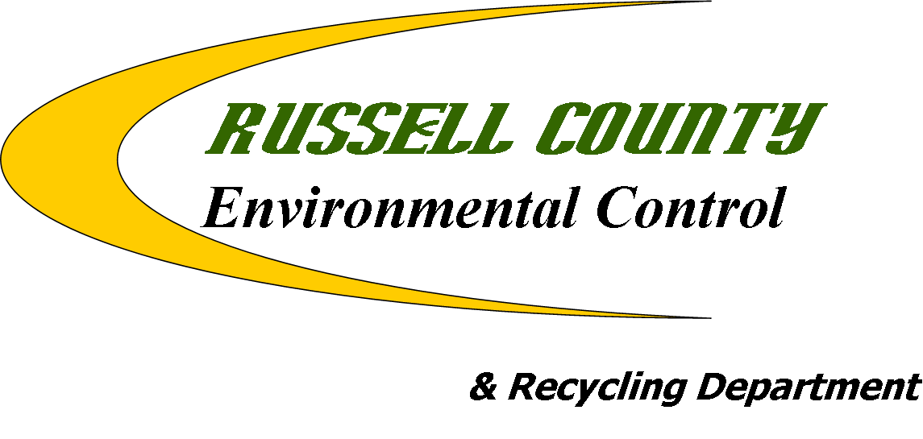

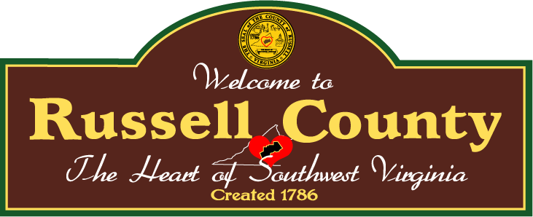

ANNUAL PLAN OF WORK

FY 2012-2013

Preface

Annual Plan of Work Purpose: The purpose of this Plan of Work is to aid the three counties with implementation of both litter prevention and recycling activities throughout the fiscal year in order to accomplish the goals they have agreed upon during the Strategic Planning meeting(s).

Definitions

The terms below are used within the Plan of Work. Therefore, they will be defined below to ensure continuity between the readers of the plan.

Goal: a statement of desired outcome or condition; what you are attempting to bring about, to improve/eliminate a problem or condition.

Objective: goals that are “objectified”, that is, stated in a measurable way.

Action Item: specific actions that will be taken by the County’s or the Cumberland Plateau Regional Waste Management Authority with assistance from the counties/partners in order to accomplish agreed upon objectives.

Tri County: means any activity, goal, objective or action item that will be accomplished as a regional effort.

Table of Contents

PURPOSE Page 4

GOAL #1----------Illegal Dumpsite Mapping and Cleanups Page 5

GOAL #2---------Litter Prevention and Assign-A-Highway Programs Page 6

GOAL #3----------Education and Outreach Programs Page 7

GOAL #4----------Enforcement Page 8

GOAL #5----------Recycling Page 9

GOAL #6----------Local Projects and Activities for Russell County Page 10

Approval and Signature Page Page 11

Purpose

Purpose: The Cumberland Plateau Regional Waste Management Authority, formed in 1991 was created to provide solid waste management duties for Buchanan, Dickenson and Russell Counties. Under this umbrella, the CPRWMA is charged with the duties of providing a regional litter prevention and recycling coordinator to assist the member county’s litter control departments. The Litter Control Departments and the CPRWMA envision the region, as being recognized as a quality place to live, be litter free and having recycling programs throughout the three counties. To that end, the Litter Control Departments of Buchanan, Dickenson and Russell and the CPRWMA will promote, initiate and implement programs that focus on litter prevention and recycling to its citizens.

Tri-County Member Counties and its Representatives

Buchanan County: Mr. Jerry Ward, Mr. Richard Lee, Mr. Earl Rife and Mr. W.J Caudill.

Dickenson County: Mr. Eugene Mullins, Mr. Lester Turner and Mr. Mark Vanover.

Russell County: Mr. Bobby Justus and Mr. Mary Carol White

CPRWMA Board of Directors and Staff: Buchanan Co. (Mr. Earl Rife and Mr. Buddy Fuller), Dickenson Co. (Mr. Damon Rasnick and Mr. Donnie Rife), and Russell Co. (Mr. Danny Brown and Mr. Frank Horton). Staff: Mr. Toby Edwards.

GOAL #1 ILLEGAL DUMPSITE MAPPING AND CLEANUPS

Russell County:

Action Item #1: By May 2013, have Russell County’s Illegal Dumpsite map updated to include new sites and sites cleaned in 2008, 2009, 2010 and 2011.

Action Item #2: By May 2013, organize and plan the cleanup of 10 illegal dumpsites using staff and volunteer groups.

Action Item #3: Continue the Hot Spot team cleanups through June 2013.

CPRWMA “Regional”:
Action Item #1: Coordinate 6 Tri County Illegal Dump Cleanups—2 in Buchanan County, November, 2 in Russell County, December and 2 in Dickenson County, December.

Action Item #2: By April 2013, assist all three Counties’ with having their dumpsites map updated to include new sites (red dots) and sites cleaned (blue dots) in 08-12.

Action Item#3: Seek out funding or grants for Illegal Dump Cleanup Equipment.

Action Item #4: Starting in November 2012, coordinate 3 Tri County Stream cleanups (1 Buchanan Co, 1 Dickenson Co and 1 Russell Co). Complete by April 2013.

Action Item #5: By June 2013, Promote Adopt-A-Dump with member counties.

GOAL #2 LITTER PREVENTION AND ASSIGN-A-HIGHWAY PROGRAM

Russell County:

Action Item #1: By June 2013, have 60% of the state maintained roads being cleaned by the Assign-A-Highway program.

Action Item #2: By June 2013, maintain a litter cleanup crew to address highway litter, illegal dumpsites, and stream cleanup events.

CPRWMA “Regional”:

Action Item #1: Coordinate with the Three Counties to assist them with reporting the number of bags cleaned by the Assign-A-Highway program to VDOT’s Adopt-A-Hwy coordinator during September and December 2012 and March and June 2013.

Action Item #3: By Oct 2012, assist the counties with having a Regional meeting with area coal and gas companies to develop a “No Litter Policy” for their employees and contractors.

Action Item #4: By March 2013, assist those counties with ADOPT-A-DUMP

Action Item #5: Encourage participation of all three counties in the Keep Southwest Virginia Beautiful meetings.

GOAL #3 EDUCATION AND OUTREACH PROGRAMS

Russell County:

Action Item #1: By December 2012, pursue Russell County Environmental Control and Recycling Department having a website or a link on the county’s homepage.

Action Item #2: Continue to develop stories and articles for local newspapers and other media outlets to create awareness and to promote events.

Action Item #3: By September 2012, assist the Clinch Valley SWCD with conducting the Natural Resources Festival for all Russell County 6th grade students.

Action Item #4: Develop partnerships schools to assist school clubs and classrooms with programs and events to promote conservation, recycling, and anti-littering.

Action Item #5: By September 2012, present awards for the winning School Beautiful schools. Judge all county schools for the Russell County Schools Beautiful Contest. Once in September 13th 2012 and once in May 2013

CPRWMA “Regional”:

Action Item #1: By June 2013, assist counties with development of a “County” Litter Control and Recycling Brochure.

Action Item #2: By January 2013, coordinate a regional recycling data collection workshop for 2007 Virginia Department of Environmental Quality recycling report.

Action Item #3: Starting in September 2012, develop and submit a monthly article to all three counties newspapers pertaining to litter prevention and recycling topics.

Action Item #4: By September 2012, assist Counties with Coordination and Implementation of the “Groundwater Festival” for 6th grade students.

Action Item #7: By August 2012, assist member counties with developing a local and regional Plan of Work.

GOAL #4 ENFORCEMENT

Russell County:

Action Item #1: Increase use of available surveillance equipment to produce court convictions. Re-evaluate usefulness of current equipment.

Action Item #2: Begin Night/Evening/Weekend patrols by September 2012.

Action Item # 3: Work with County Administrator, County Attorney, and County Board of Supervisors to develop stronger ordinances for environmental violations by December 2012.
Action Item #4: Develop a patrol schedule for the County’s Solid Waste Collection Centers.

CPRWMA “Regional”:

Action Item #1: By December 2012, assist Russell County with incorporation of the Civil Law suit into their County’s Litter Ordinance. Assist with meetings with the county officials and Judges on prosecuting litters using the Civil Law suit.

Action Item #2: By June 2013, provide training on enforcement “tools” that each county request training.

Action Item #3: By April 2013, encouraged member counties with implementation of an anti-cigarette butt campaign-“Don’t be a Butt Head” “Keep Your Butt in the Car” “Take Care of Your Own Butt”.

Action Item #4: By June 2013, provide assistance to the counties on educating Judges on our regional approach and civil law suit-potentially a regional meeting for the Judges.

GOAL #5 RECYCLING

Russell County:

Action Item #1: Conduct the annual Clean Your Files Day by April 2013.

Action Item #2: Continue to encourage office paper-recycling consoles in area businesses and county offices.

Action Item #3: Develop Aluminum Can Roundup and Paper Recycling programs for schools and complete by June 2013.

Action Item #4: Conduct biannual Household Hazardous Waste Collection Events by April 14, 2013.

Action Item #5: Conduct a Recycling Bin Grant program through the Russell County School System from September 2012 through June 2013

Action Item #6: By August 2012, continue the Plastic Bag recycling program for schools and complete by April 2013.

Action Item #7: By April 9, 2013, conduct Office Paper Shredding and Electronics Recycling Day and increase materials collected to 10 tons.

CPRWMA “Regional”:

Action Item #1: By April 2013, assist the counties with coordination, advertisement and implementation of 1 Electronics Recycling event in each county.

Action Item #2: By March 2013, assist the three counties with the continuation of a Clean Your Files Day.

Action Item #3: By November 2012, expand cardboard recycling and office paper recycling in all three Counties.

Action Item #4: By April 2013, assist all three counties with the development and implementation of a Household Hazardous Waste Collection day.

Action Item #5: Pursue with each county opportunity to expand their current recycling programs—i.e. grants, vendors and locations.

Action Item #6: By November 2012, coordinate a “field trip” to the Creative Recycling Solution computer recycling facility.

Action Item #7: By September 2012, assist counties with implementing a Plastic Bag recycling contest between schools.

GOAL #6 LOCAL PROJECTS AND ACTIVITIES FOR RUSSELL COUNTY

Russell County:

Action Item #1: By March 30, 2013, complete annual recycling rate report and submit to the CPRWMA.

Action Item #2: By May 2013, conduct annual spring cleanup and increase volunteer groups.

Action Item #3: By October 2012, participate and assist with coordinating Clean Virginia Waterways annual waterways cleanup event.

Action Item #4: Do KAB affiliate report by August 2012 and semiannual report by June 2013.

Action Item #5: Bu June 2013, complete DEQ Annual Litter and Recycling grant application and report.

Action Item #7: By June 2013, request for additional personnel and equipment for the Russell County Environmental Control and Recycling Department.

Action Item #8: Participate and attend the Keep Southwest Virginia Beautiful meetings.

Action Item #9: By May 2013, utilize probationers to clean 10 illegal dumps.

FY 2012-2013 ANNUAL PLAN OF WORK
APPROVAL DOCUMENTATION SHEET

The Russell County Environmental Control Office’s Annual Plan of Work for FY 2012-2013 was reviewed and approved on August 4, 2012. This plan will remain in effect until June 30, 2013.

________________________________
Mr. Bobby Justus
Russell County Environmental Enforcement Officer

________________________________
Ms. Marycarol White
Russell County Administrator

________________________________
Date

