Dickenson County
Litter Enforcement and Recycling Department

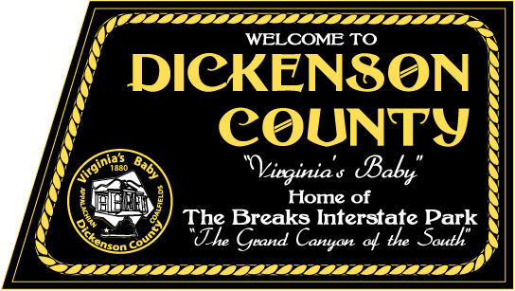

ANNUAL PLAN OF WORK

FY 2012-2013

Preface

Annual Plan of Work Purpose: The purpose of this Plan of Work is to aid Dickenson County’s Litter Control Department staff with implementation of both litter prevention and recycling activities through out the fiscal year in order to accomplish the goals they have agreed upon during the Strategic Planning meeting(s).

Definitions

The terms below are used within the Plan of Work. Therefore, they will be defined below to ensure continuity between the readers of the plan.

Goal: a statement of desired outcome or condition; what you are attempting to bring about, to improve/eliminate a problem or condition.

Objective: goals that are “objectified”, that is, stated in a measurable way.

Action Item: specific actions that will be taken by the County’s or the Cumberland Plateau Regional Waste Management Authority with assistance from the counties/partners in order to accomplish agreed upon objectives.

Tri County: means any activity, goal, objective or action item that will be accomplished as a regional effort.

Table of Contents

PURPOSE Page 4

GOAL #1----------Illegal Dumpsite Mapping and Cleanups Page 5

GOAL #2---------Litter Prevention and Assign-A-Highway Programs Page 6

GOAL #3----------Education and Outreach Programs Page 7

GOAL #4----------Enforcement Page 9

GOAL #5----------Recycling Page 10

GOAL #6----------Local Projects and Activities for Dickenson County. Page 12

Approval and Signature Page Page 13

Purpose

Purpose: The Cumberland Plateau Regional Waste Management Authority, formed in 1991 was created to provide solid waste management duties for Buchanan, Dickenson and Russell Counties. Under this umbrella, the CPRWMA is charged with the duties of providing a regional litter prevention and recycling coordinator to assist the member county’s litter control departments. The Litter Control Departments and the CPRWMA envision the region, as being recognized as a quality place to live, be litter free and having recycling programs throughout the three counties. To that end, the Litter Control Departments of Buchanan, Dickenson and Russell and the CPRWMA will promote, initiate and implement programs that focus on litter prevention and recycling to its citizens.

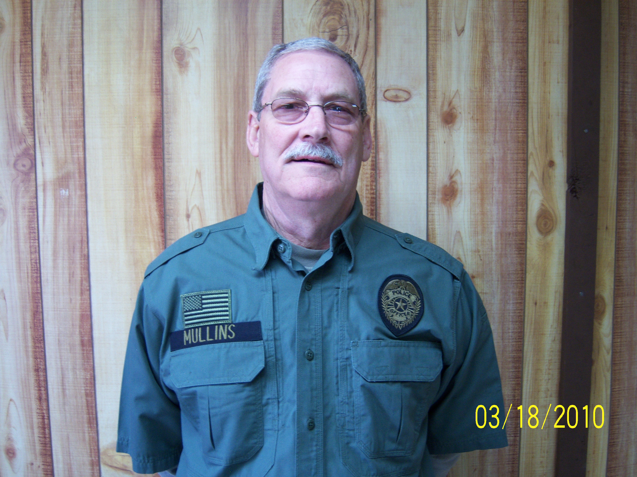
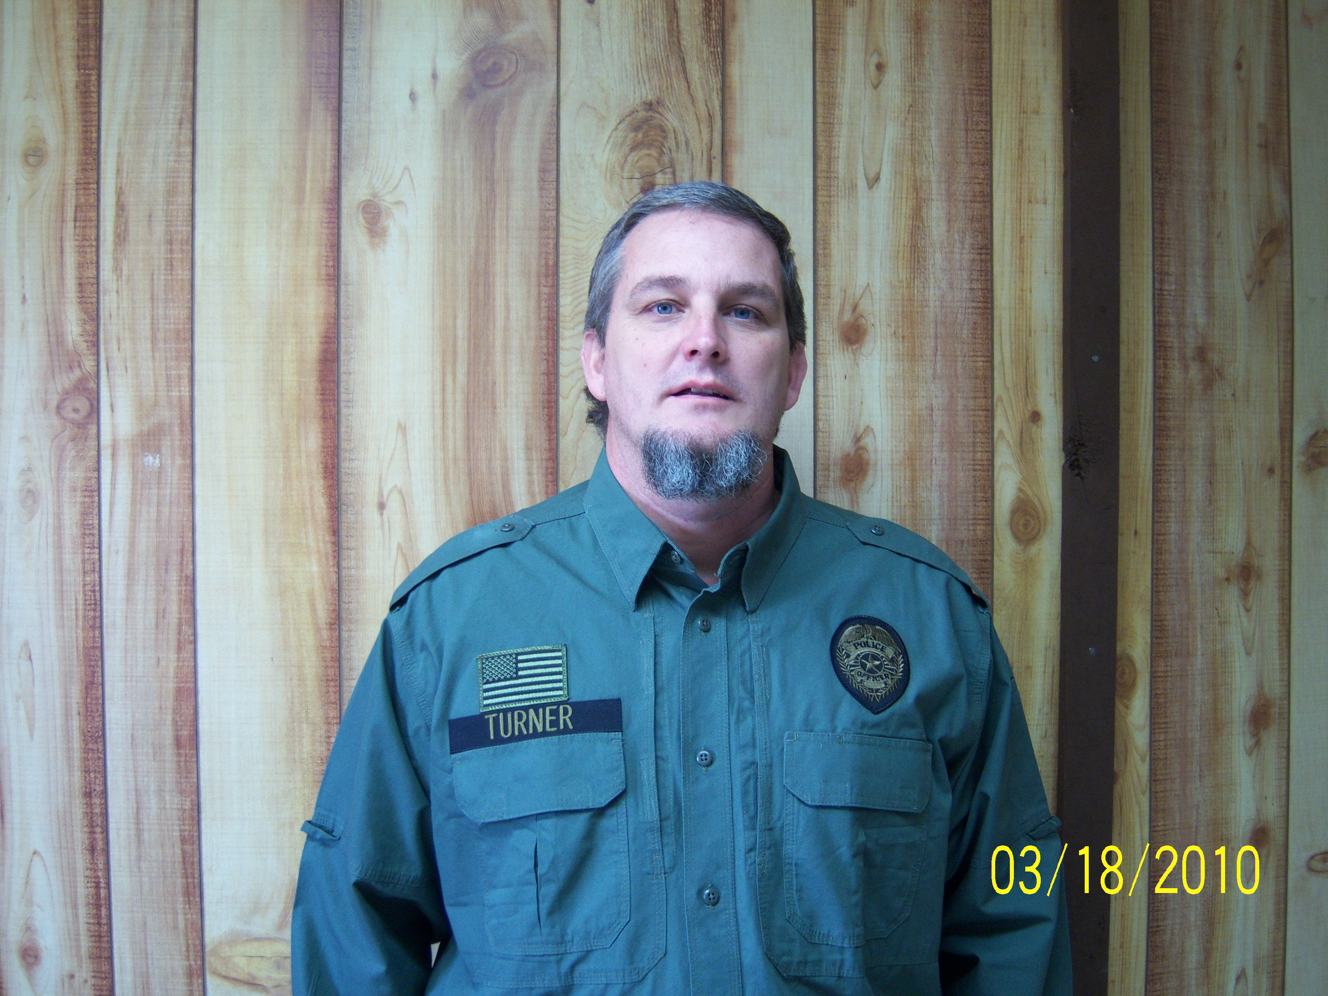

Mr. Eugene Mullins, DC Recycling Coordinator Mr. Lester Turner, DC Litter Officer

Tri-County Member Counties and its Representatives

Buchanan County: Mr. Jerry Ward, Mr. Richard Lee and Mr. Earl Rife.

Dickenson County: Mr. Eugene Mullins and Mr. Lester Turner

Russell County: Mr. Bobby Justus, Mr. Odell Musick, and Mr. Terry Lowe

CPRWMA Board of Directors and Staff: Buchanan Co. (Mr. Earl Rife and Mr. Buddy Fuller), Dickenson Co. (Mr. Damon Rasnick and Mr. Donnie Rife), and Russell Co. (Mr. Danny Brown and Mr. Frank Horton). Staff: Mr. Toby Edwards.

GOAL #1 ILLEGAL DUMPSITE MAPPING AND CLEANUPS

Dickenson County:

Action Item #1: By December 31, 2012, have Dickenson County’s Illegal Dumpsite map updated to include new sites and sites cleaned in 2010-2011.

Action Item #2: By May 2013, organize and plan the cleanup of 12 illegal dumpsites using staff and citizens groups.

Action Item # 3: Beginning in January 2013, update Dickenson County Litter Control website each month. Also add a page to identified Illegal dumpsites and dump sites that are cleaned.

Action Item #4: By December 2012, implement Adopt-A-Dump program and have 2 groups adopt an identified dump for cleanup.

Action Item #5: By December 2012, have 2 Boy Scout troops adopt an illegal dump.

Action Item #6: By November 2012, continue Abandoned Structures Survey with the assistance of Dickenson County Building Department.

CPRWMA “Regional”:

Action Item #1: Coordinate 6 Tri County Illegal Dump Cleanups—2 in Buchanan County, November, 2 in Russell County, December, and 2 in Dickenson County, December.

Action Item #2: By April 2012, assist all three Counties’ with having their dumpsites map updated to include new sites (red dots) and sites cleaned (blue dots) in 08-11.

Action Item#3: Seek out funding or grants for Illegal Dump Cleanup Equipment.

Action Item #4: Starting in November 2011, coordinate 3 Tri County Stream cleanups (1 Buchanan Co, 1 Dickenson Co and 1 Russell Co). Complete by April 2012.

Action Item #5: By June 2012, Promote Adopt-A-Dump with member counties.

GOAL #2 LITTER PREVENTION AND ASSIGN-A-HIGHWAY PROGRAM

Dickenson County:

Action Item #1: Maintain Dickenson Co Assign-A-Highway program at 50% of the state maintained roads being cleaned every week.

Action Item #2: By December 2012, have an Assign-A-Hwy partners meeting with Litter Control staff, CPRWMA staff, Judge, Probation Officers and Virginia Department of Transportation.

Action Item #3: Report number of bags cleaned by the Assign-A-Highway program to VDOT’s Adopt-A-Highway coordinator during September and December 2011 and March and June 2012.

Action Item #4: By December 2012, implement an awards ceremony to recognize probationers and citizens.

CPRWMA “Regional”:

Action Item #1: Coordinate with the Three Counties to assist them with reporting the number of bags cleaned by the Assign-A-Highway program to VDOT’s Adopt-A-Hwy coordinator during September and December 2011 and March and June 2010.

Action Item #3: By Oct 2012, assist the counties with having a Regional meeting with area coal and gas companies to develop a “No Litter Policy” for their employees and contractors.

Action Item #4: By March 2012, assist those counties with ADOPT-A-DUMP

Action Item #5: Encourage participation of all three counties in the Keep Southwest Virginia Beautiful meetings.

GOAL #3 EDUCATION AND OUTREACH PROGRAMS

Dickenson County:
Action Item #1: Conduct Litter Prevention and Recycling activities to all students within the county starting in May 2013.

Action Item #2: By September 2012, complete School Beautiful Program to Dickenson County Schools. Judging will be conducted in September 14 2011 and May 2012.

Action Item #3: By December 2012, expand the DCLC monthly newspaper article in the Dickenson Star.

Action Item #4: By March 2013, implement Trash Art Contest to all county schools.

Action Item #5: By May 2013, judge all county schools for the Dickenson County Schools Beautiful Contest.

Action Item #6: By February 2013, implement a countywide Aluminum Can Recycling event for schools.

Action Item #7: By December 2012, Implement Dickenson County Litter Free School Zone Program at all schools.

Action Item #8: By March 2013, have at least 1 student organization at each school pickup litter.

Action Item #9: By June 2013, give presentations to at least 5 different civic groups within the county. One per calendar month.

Action Item #10: By February 2013, Conduct a Workshop for Chamber of Commerce on Office Recycling.

Action Item #11: By October 2012, Implement the Groundwater Festival for all Dickenson County 6th grade students.

CPRWMA “Regional”:

Action Item #1: By June 2013, assist counties with development of a “County” Litter Control and Recycling Brochure.

Action Item #2: By January 2013, coordinate a regional recycling data collection workshop for 2007 Virginia Department of Environmental Quality recycling report.

Action Item #3: Starting in September 2012, develop and submit a monthly article to all three counties newspapers pertaining to litter prevention and recycling topics.

Action Item #4: By September 2012, assist Counties with Coordination and Implementation of the “Groundwater Festival” for 6th grade students.

Action Item #7: By August 2012 assist member counties with developing a local and regional Plan of Work.

GOAL #4 ENFORCEMENT

Dickenson County:

Action Item #1: Conduct 7 night time patrols to catch litter bugs-one per month starting in August 2012.

Action Item #2: By February 2013, Work with County Judges on prosecuting litters using the Civil Lawsuit. Conduct meeting with County officials and lawyers

Action Item #3: By October 2012, continue the KAB Cigarette Butt Campaign being promoted by Keep SWVA Beautiful.

Action Item #4: By September 2012, participate in the Regional Groundhog Camera Month.

CPRWMA “Regional”:

Action Item #1: By December 2012, assist Russell County with incorporation of the Civil Law suit into their County’s Litter Ordinance. Assist with meetings with the county officials and Judges on prosecuting litters using the Civil Law suit.

Action Item #2: By June 2013, provide training on enforcement “tools” that each county request training.

Action Item #3: By April 2013, encouraged member counties with implementation of an anti-cigarette butt campaign-“Don’t be a Butt Head” “Keep Your Butt in the Car” “Take Care of Your Own Butt”.

Action Item #4: By June 2013, provide assistance to the counties on educating Judges on our regional approach and civil law suit-potentially a regional meeting for the Judges.

GOAL #5 RECYCLING

Dickenson County:

Action Item #1: Attend Regional Training on Recycling Counting hosted by the Cumberland Plateau Regional Waste Management Authority in January 2013.

Action Item #2: Implement a Clean Your Files Day in June or July 2013.

Action Item #3: By August 2012, implement school plastic bag recycling contest in all elementary/middle schools and complete in April 2013.

Action Item #4: Attend tour of a similar county’s recycling program that CPRWMA will host.

Action Item #5: Starting in April 13 2013, implement more newspaper, flyers, etc. to encourage citizens to recycle their Electronics and host a Electronics Recycling Day by September 9 2012. Increase materials collected to 6 tons.

Action Item #6: By April 14 2013, Conduct 1 Household Hazardous Waste Collection Event.

Action Item #7: By September 6th 2012, promote Dickenson County’s Recycling Drop-off site-in the newspaper, awareness day, radio advertisement, etc.

CPRWMA “Regional”:

Action Item #1: By April 2013, assist the counties with coordination, advertisement and implementation of 1 Electronics Recycling event in each county.

Action Item #2: By March 2013, assist the three counties with the continuation of a Clean Your Files Day.

Action Item #3: By November 2012, expand cardboard recycling and office paper recycling in all three Counties.

Action Item #4: By April 2013, assist all three counties with the development and implementation of a Household Hazardous Waste Collection day.

Action Item #5: Pursue with each county opportunity to expand their current recycling programs—i.e. grants, vendors and locations.

Action Item #6: By November 2012, coordinate a “field trip” to the Creative Recycling Solution computer recycling facility.

Action Item #7: By September 2012, assist counties with implementing a Plastic Bag recycling contest between schools.

GOAL #6 LOCAL PROJECTS AND ACTIVITIES FOR DICKENSON

Dickenson County:

Action Item #1: By May 2013, conduct annual spring cleanup and increase volunteer groups by 3 new civic groups.

Action Item #2: By March 2013, complete annual recycling rate report and submit to the CPRWMA.

Action Item #3: By June 2013, continue pickup of appliances.(All Year)

Action Item #4: By October 2012, Participate in Clean Virginia’s Waterways and clean up at least 3 tons of materials.

Action Item #5: Participate and attend the UTRR’s Keep Southwest VA Beautiful meetings at least 4 times.

Action Item #6: Attend the Lonesome Pine Soil and Water Conservation District’s board meetings at least quarterly, starting in September 2012.

Action Item #7: Starting in September 2012, attend 4 Dickenson County Board of Supervisors meetings.

Action Item #8: Starting in October 2012, conduct roadside cleanup of 10 mile sections each month until June 2013.

Action Item #9: Starting in November 2012, utilize probationers to clean 10 illegal dumps.

Action Item #10: By October 2012, implement a new answering program for the Assign-A-Highway program.

Action Item #11: By May 2013, assist with the development and installation of at least 1 Outdoor Classroom at a Dickenson County School.

Action Item #12: By Fall of 2012, assist the Lonesome Pine SWCD with 3 events targeted for school children-example Kids In the Creek.

Action Item #13: By June 2013, complete the VADEQ grant application and annual grant report.

Action Item #14: DO KAB Affiliate report by August 12 and semiannual report by June 2013

FY 2012-2013 ANNUAL PLAN OF WORK
APPROVAL DOCUMENTATION SHEET

The Dickenson County Litter Control Office’s Annual Plan of Work for FY 2012-2013 was reviewed and approved on August 1, 2012. This plan will remain in effect until June 30, 2013.

________________________________
Mr. David Moore, Administrator
Dickenson County Board of Supervisors

________________________________
Mr. Eugene Mullins
Coordinator, Dickenson County Litter Enforcement and Recycling

________________________________
Mr. Lester Turner
Dickenson County Litter Enforcement Officer

________________________________
Date

