Buchanan County
Litter Enforcement and Recycling Department

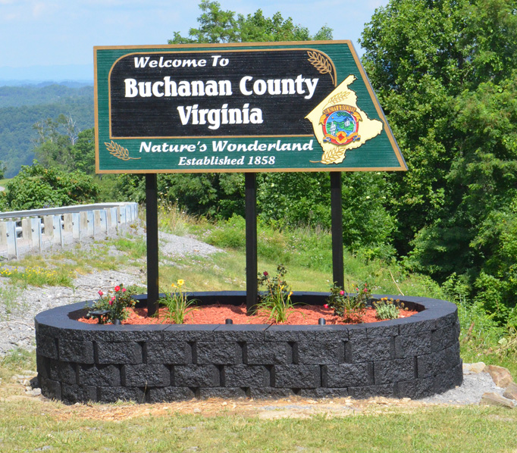

ANNUAL PLAN OF WORK

FY 2012-2013

Preface

Annual Plan of Work Purpose: The purpose of this Plan of Work is to aid Buchanan County’s Litter Control Department staff with implementation of both litter prevention and recycling activities through out the fiscal year in order to accomplish the goals they have agreed upon during the Strategic Planning meeting(s).

Definitions

The terms below are used within the Plan of Work. Therefore, they will be defined below to ensure continuity between the readers of the plan.

Goal: a statement of desired outcome or condition; what you are attempting to bring about, to improve/eliminate a problem or condition.

Objective: goals that are “objectified”, that is, stated in a measurable way.

Action Item: specific actions that will be taken by the County’s or the Cumberland Plateau Regional Waste Management Authority with assistance from the counties/partners in order to accomplish agreed upon objectives.

Tri County: means any activity, goal, objective or action item that will be accomplished as a regional effort.

Table of Contents

PURPOSE Page 4

GOAL #1----------Illegal Dumpsite Mapping and Cleanups Page 5

GOAL #2---------Litter Prevention and Assign-A-Highway Programs Page 6

GOAL #3----------Education and Outreach Programs Page 7

GOAL #4----------Enforcement Page 9

GOAL #5----------Recycling Page 10

GOAL #6----------Local Projects and Activities for Buchanan County. Page 12

Approval and Signature Page Page 13

Purpose

Purpose: The Cumberland Plateau Regional Waste Management Authority, formed in 1991 was created to provide solid waste management duties for Buchanan, Dickenson and Russell Counties. Under this umbrella, the CPRWMA is charged with the duties of providing a regional litter prevention and recycling coordinator to assist the member county’s litter control departments. The Litter Control Departments and the CPRWMA envision the region, as being recognized as a quality place to live, be litter free and having recycling programs throughout the three counties. To that end, the Litter Control Departments of Buchanan, Dickenson and Russell and the CPRWMA will promote, initiate and implement programs that focus on litter prevention and recycling to its citizens.

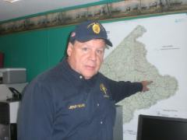
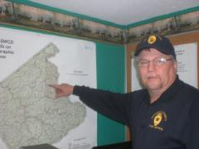

Litter and Recycling Coordinator Litter Enforcement Officer
Mr. Jerry Ward Mr. Richard Lee

Tri-County Member Counties and its Representatives

Buchanan County: Mr. Jerry Ward, Mr. Richard Lee and Mr. Earl Rife.

Dickenson County: Mr. Eugene Mullins and Mr. Lester Turner

Russell County: Mr. Bobby Justus, Mr. Odell Musick, and Mr. Terry Lowe

CPRWMA Board of Directors and Staff: Buchanan Co. (Mr. Earl Rife and Mr. Buddy Fuller), Dickenson Co. (Mr. Damon Rasnick and Mr. Donnie Rife), and Russell Co. (Mr. Danny Brown and Mr. Frank Horton). Staff: Mr. Toby Edwards.

GOAL #1 ILLEGAL DUMPSITE MAPPING AND CLEANUPS

Buchanan County:

Action Item #1: By April 2013, have Buchanan County’s Illegal Dumpsite map updated to include new sites and sites cleaned in 2009-10 and coordinate with both the E911 office and the Big Sandy Soil and Water Conservation District.

Action Item #2: By May 2013, organize and plan the cleanup of 25 illegal dumpsites using staff and citizens groups.

Action Item #3: By February 2013, implement Adopt-A-Dump program and have 4 “new” groups adopt an identified dump for cleanup.

Action Item #4: By December 2012, install 25 Anti-dumping signs.

Action Item #5: By March 2013, promote community groups cleaning litter along streams-example use of the VA DCR Adopt-A-Stream program.

Action Item #6: By January 2013, Map the remaining abandoned buildings/homes along Rt. 460, Rt. 83 and Rt. 80 and send letters to owners.

Action Item #7: By October 2012, work with 911 on illegal dump and Abandoned Home maps.

CPRWMA “Regional”:
Action Item #1: Coordinate 6 Tri County Illegal Dump Cleanups—2 in Buchanan County, November, 2 in Russell County, December, and 2 in Dickenson County, December.

Action Item #2: By April 2013, assist all three Counties’ with having their dumpsites map updated to include new sites (red dots) and sites cleaned (blue dots) in 08-12.

Action Item#3: Seek out funding or grants for Illegal Dump Cleanup Equipment.

Action Item #4: Starting in November 2012, coordinate 3 Tri County Stream cleanups (1 Buchanan Co, 1 Dickenson Co and 1 Russell Co). Complete by April 2012.

Action Item #5: By June 2013, Promote Adopt-A-Dump with member counties.

GOAL #2 LITTER PREVENTION AND ASSIGN-A-HIGHWAY PROGRAM

Buchanan County:

Action Item #1: By June 2013, have 50% of the state and county roads being cleaned by the Assign-A-Highway program.

Action Item #2: By September 2012, have an Assign-A-Hwy partners meeting with Litter Control staff, CPRWMA staff, Judge, Probation Officers and Virginia Department of Transportation.

Action Item #3: By June 2013, develop program to utilize community service workers for litter prevention activities.

Action Item #4: Report number of bags cleaned by the Assign-A-Highway program to VDOT’s Adopt-A-Hwy coordinator during September and December 2011 and March and June 2013.

Action Item #5: By April 2013, implement an awards ceremony to recognize probationers (gift card for probationers) and citizens (plaques).

Action Item #6: By October 2012, coordinate with regional jail on highway cleanups in Buchanan County.

CPRWMA “Regional”:

Action Item #1: Coordinate with the Three Counties to assist them with reporting the number of bags cleaned by the Assign-A-Highway program to VDOT’s Adopt-A-Hwy coordinator during September and December 2012 and March and June 2013.

Action Item #3: By Oct 2012, assist the counties with having a Regional meeting with area coal and gas companies to develop a “No Litter Policy” for their employees and contractors.

Action Item #4: By March 2013, assist those counties with ADOPT-A-DUMP

Action Item #5: Encourage participation of all three counties in the Keep Southwest Virginia Beautiful meetings.

GOAL #3 EDUCATION AND OUTREACH PROGRAMS

Buchanan County:
Action Item #1: By Ongoing, update Buchanan County Litter Control Department’s website monthly starting in September 2012.

Action Item #2: Continue the Trash Talk article with the Virginia Mountaineer newspaper, monthly litter or recycling article- Ongoing.

Action Item #3: By March 2013, implement Poster Contest for all 4th to 12th grade students.

Action Item #4: By March 2013, implement Trash Art Contest to all county schools.

Action Item #5: By September 2012, present awards for the winning School Beautiful schools. Judge all county schools for the Buchanan County Schools Beautiful Contest. Once in September 13th 2012 and once in May 2013.

Action Item #6: By November 2012, conduct Recycling Challenge (CD) presentations to at least 541 2nd and 3rd grade students.

Action Item #7: By October 2012, conduct Who Wants To Be An Environmental Millionaire computer game to 6th-grade students at Groundwater Festival.

Action Item #8: By September 11, 2012, conduct a cleanup at the Liberty Garden located at Riverview Elem/Middle and Buchanan Co Transfer Station.

Action Item #9: By January 2013, pursue the hiring of an education specialist and schedule presentations to schools as outlined in Action Item’s #3, 4, 5, 6, & 7.

Action Item #10: By May 2013, have all schools become members of Virginia Naturally Program.

Action Item #11: By June 2013, have 2 schools equipped with outdoor classrooms. Work with the Big Sandy SWCD to accomplish this action item.

Action Item #12: By December 2012, reprint the Buchanan County litter and recycling office brochure.

CPRWMA “Regional”:

Action Item #1: By June 2013, assist counties with development of a “County” Litter Control and Recycling Brochure.

Action Item #2: By January 2013, coordinate a regional recycling data collection workshop for 2007 Virginia Department of Environmental Quality recycling report.

Action Item #3: Starting in September 2012, develop and submit a monthly article to all three counties newspapers pertaining to litter prevention and recycling topics.

Action Item #4: By September 2012, assist Counties with Coordination and Implementation of the “Groundwater Festival” for 6th grade students.

Action Item #7: By August 2012, assist member counties with developing a local and regional Plan of Work.

GOAL #4 ENFORCEMENT

Buchanan County:

Action Item #1: By February 2013, written 10 tickets for trash blowing out of vehicles (improperly secured loads).

Action Item #2: By March 2013, Obtain convictions of person illegally dumping using the Groundhog Camera and deploying the camera at least 100 times.

Action Item #3: By March 2013, Obtain 100 cases of illegal dumping in addition to the groundhog camera.

Action Item #4: By April 2013, Conduct 20 night time Patrol.

Action Item #5: January 2013, Obtained 10 cigarette littering convictions through general district court.

Action Item #7: By December 2012, develop and implement Buchanan County Environmental court. Have 2 days of court per month.

CPRWMA “Regional”:

Action Item #1: By December 2012, assist Russell County with incorporation of the Civil Law suit into their County’s Litter Ordinance. Assist with meetings with the county officials and Judges on prosecuting litters using the Civil Law suit.

Action Item #2: By June 2013, provide training on enforcement “tools” that each county request training.

Action Item #3: By April 2013, encouraged member counties with implementation of an anti-cigarette butt campaign-“Don’t be a Butt Head” “Keep Your Butt in the Car” “Take Care of Your Own Butt”.

Action Item #4: By June 2013, provide assistance to the counties on educating Judges on our regional approach and civil law suit-potentially a regional meeting for the Judges.

GOAL #5 RECYCLING

Buchanan County:

Action Item #1: Attend Regional Training on Recycling Counting hosted by the Cumberland Plateau Regional Waste Management Authority in January 2013.

Action Item #2: Implement a Clean Your Files Day in June or July 2013.

Action Item #3: Increase Abandoned Car Program to 50 cars per year. (160 for 2012 -2013).

Action Item #4: By April 2013, installed 20 recycling containers in area businesses and schools.

Action Item #5: By October 2012, Pursue getting cardboard recycling trailer in Buchanan County.

Action Item #6: By October 2012, investigate the purchase of a mobile recycling trailer.

Action Item #7: Attend tour of a similar county’s recycling program that CPRWMA will host.

Action Item #8: By May 2013, Encourage 5 new schools to recycle Printer cartridges.

Action Item #9: By September 2012, continue the Plastic Bag recycling program for schools and complete by April 2013.

Action Item #10: By April 20, 2013, conduct Office Paper Shredding and Electronics Recycling Day and increase materials collected to 10 tons.

Action Item #11: By April 21, 2013, Conduct 1 Household Hazardous Waste Collection Event in conjunction with Earth Day.

Action Item #12: By May 2013, implement a recycling program at all schools- cardboard, paper and plastic.

CPRWMA “Regional”:

Action Item #1: By April 2013, assist the counties with coordination, advertisement and implementation of 1 Electronics Recycling event in Russell County.

Action Item #2: By March 2013, assist the three counties with the continuation of a Clean Your Files Day.

Action Item #3: By November 2012, expand cardboard recycling and office paper recycling in all three Counties.

Action Item #4: By April 2013, assist all three counties with the development and implementation of a Household Hazardous Waste Collection day.

Action Item #5: Pursue with each county opportunity to expand their current recycling programs—i.e. grants, vendors and locations.

Action Item #6: By November 2012, coordinate a “field trip” to the Creative Recycling Solution computer recycling facility.

Action Item #7: By September 2012, assist counties with implementing a Plastic Bag recycling contest between schools.

GOAL #6 LOCAL PROJECTS AND ACTIVITIES FOR BUCHANAN COUNTY

Buchanan County:

Action Item #1: By March 30, 2013, complete annual recycling rate report and submit to the CPRWMA.

Action Item #2: By June 2013, coordinate and attend up to 12 Keep Buchanan County Beautiful meetings-one per month.

Action Item #3: By August 2012, coordinate and implement the Keep America Beautiful Litter Index.

Action Item #4: Do KAB Affiliate Report by August 2012 and Semiannual Report by June 2013

Action Item #5: By June 2013, complete DEQ Annual Litter and Recycling grant application and report.

Action Item #6: By April 2013, the Buchanan County Litter Control Department will purse giving 5 presentations to area civic groups.

Action Item #7: By October 2012, Coordinate and develop a subcommittee for litter watch programs as a part of Keep Buchanan County Beautiful.

Action Item #8: By September 2012, develop and implement a Plastic bag recycling drive in all elementary schools in Buchanan County.

FY 2012-2013 ANNUAL PLAN OF WORK
APPROVAL DOCUMENTATION SHEET

The Buchanan County Litter Control Office’s Annual Plan of Work for FY 2012-2013 was reviewed and approved on August 1, 2012. This plan will remain in effect until June 30, 2013.

________________________________
Mr. Jerry Ward
Buchanan County Litter and Recycling Coordinator

________________________________
Mr. Richard Lee
Buchanan County Litter Enforcement Officer

_________________________________
Mr. Craig Horn, Administrator
Buchanan County

________________________________
Date

